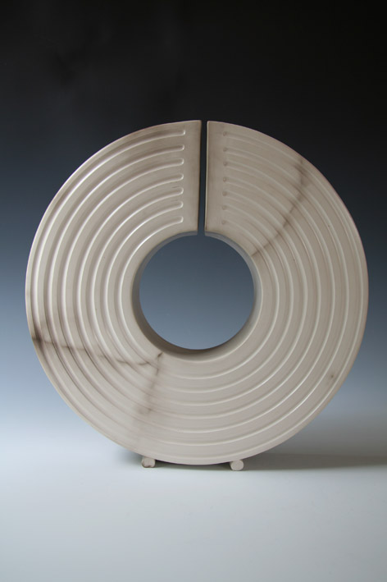

Process and Form

There is a quiet focused intensity in the design, experimentation and craftsmanship of transforming soft clay to finished hollow sculpture. Most sculptures are hand built, some works are thrown and altered; all of them are honed over many days. The slow speed of making means that the emerging form is always in process and changing. Every finished form is hand burnished several times as it dries out, to create a satin surface suitable for firing.

Once the works are bisque fired they are placed in a smoke-firing for three days. The unique colouration and marks result from several factors: the wood species, texture of fuel, the location of the sculpture within the kiln, and the weather. Each sculpture has a clear strong form and line, and the smoking imparts dramatic spontaneous flashes or subtle clouds of carbon, which create timeless finishes.

There are recurring themes in the forms I make and am inspired by: Always a strong underlying geometry, line and edges that appear effortless. Surface carving and textures are integral to the form. I am greatly inspired by the landscape and natural forms, archaeological artefacts and 20st century sculpture.

Photo: Marbled Ring